**Field Technician Routing & Navigation System**

**1. Overview**

The **Field Technician Routing & Navigation System**  is designed to streamline the process of identifying and locating downed network points reported by customers. The system minimizes delays by automatically collecting location data and prioritizing issues, enabling technicians to **navigate directly to the problem site using Google Maps** without needing to contact customers. It helps technicians easily reach the location of technical problems, reducing confusion and travel time.

**2. Process Flow**

1. **Customer Reports Issue**: A customer experiencing network issues calls the customer service number **994**.
2. **Agent Logs the Ticket**: The 994 agent registers the issue and generates a **Ticket Tracking (TT) number**.
3. **Agent Sends Link & TT Number**: The agent sends a confirmation link via SMS to the customer's mobile device and also shares the TT number.
4. **Customer Shares Location**: The customer clicks the link sent via SMS, confirming and submitting their GPS location to the system.
5. **System Logs Location**: The system associates the received location with the TT number and stores it.
6. **Prioritization Engine**: The system ranks downed network points based on predefined criteria (e.g., customer count, area importance).
7. **Technician Dashboard**: Technicians view a prioritized list of incidents with exact map locations.
8. **Navigation to Site**: Using Google Maps integration, technicians are directed to the problem site.

**3. Key Features**

* **Automatic Detection**: System identifies downed points in real time.
* **Priority Sorting**: Ensures critical network issues are resolved first.
* **Customer Location Capture**: GPS data is submitted through confirmation links.
* **Google Maps Integration**: Enables direct navigation to the site.
* **Efficient Workflow**: No customer follow-up needed to get directions.

**4. System Components**

* **Frontend (Technician Interface)**: Displays prioritized list and Google Maps links.
* **Backend Server**: Handles ticket logging, location capture, data storage, and prioritization.
* **Database**: Stores TT numbers, customer locations, issue statuses.
* **Mobile Web Interface**: Used by customers to confirm and submit GPS position via the SMS link.

**5.**

**System Model Diagram**

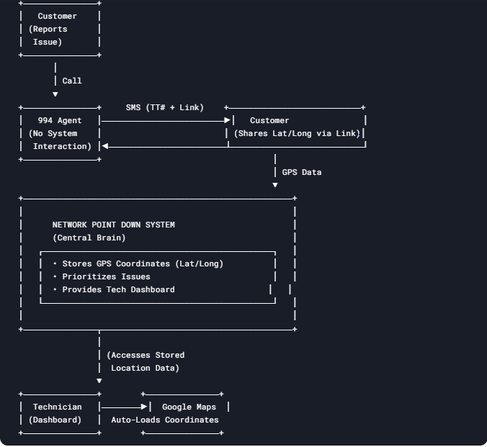

**

**6. Benefits**

* **Reduces Technician Travel Time**
* **Increases Location Accuracy**
* **Improves Customer Experience**
* **Reduces Operational Load on Call Center**
* **Helps Technicians Easily Navigate to the Problem Site**

**7. Future Enhancements**

* **Live Technician Tracking**
* **Automated Repair Logs**
* **Customer Feedback System**
* **Real-time Outage Heatmaps**

**8. Contact**

For more information , contact:  
📧yonas.mulugetat@ethiotelecom.et